190905104
Parth Shukla
Lab 6, 7, 8

Recursive descent parser

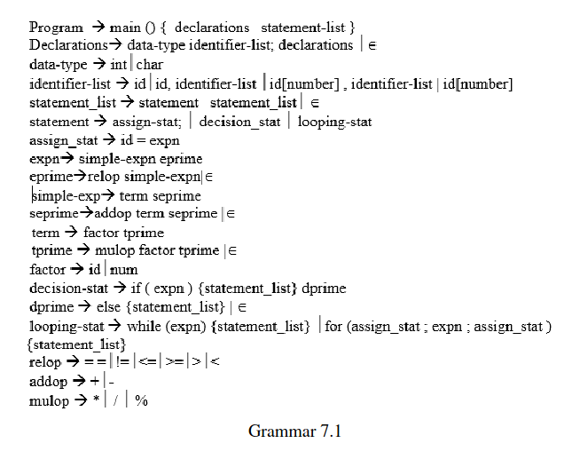
Lab 6
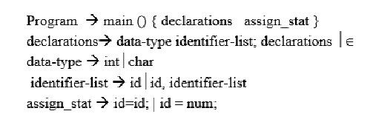
Input program

#include <stdio.h>
#include <stdlib.h>

int main(){
int a, b;
char c;
a = b;
c = 'C';
}

Output
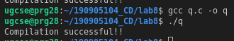

Input program
#include <stdio.h>
#include <stdlib.h>

int main(){
int a, b;
char c // missing ;
a = b;
c = 'C';
}

Output
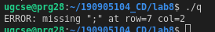

Input program
#include <stdio.h>
#include <stdlib.h>

int main(){
a, b; // invalid assignment
char c;
a = b;
c = 'C';
}
Output
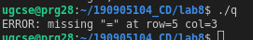

Lab 7
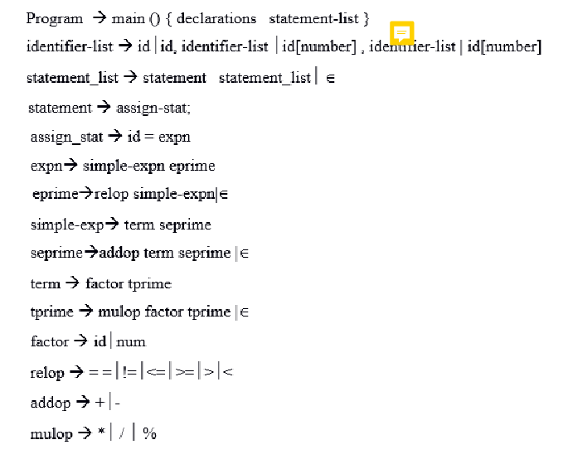
Input program

#include <stdio.h>
#include <stdlib.h>

int main(){
char c;
int first, second, third[5];

first = second;
first = 5*7;
first = 5>7;
}
Output

Input program
#include <stdio.h>
#include <stdlib.h>

int main(){
char c;
int first, second, third[5];

first = second;
first = 5%%7; // invalid operator
first = 5>7;
}
Output
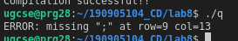

Input program
#include <stdio.h>
#include <stdlib.h>

int main(){
char c;
int first second, third[5]; // missing ,

first = second;
first = 5%7;
first = 5>7;
}
Output
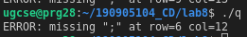

Lab 8

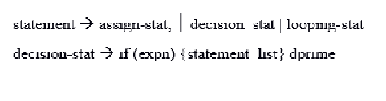

Input program
#include <stdio.h>
#include <stdlib.h>

int main()
{
int a, b;
char c;
int first, second, third[5];

while (a <= b)
{
if (second <= 5)
{
for (b = 0; b<=10; b = b + 1)
{
a = second;
}
}
}
if (second != first)
{
c = 1;
}
else
{
c = 2;
}
}
Output

Input program
#include <stdio.h>
#include <stdlib.h>

int main()
{
int a, b;
char c;
int first, second, third[5];

while (a <= b)
{
if (second <= 5)
{
for (b = 0; b<=10; b = b + 1)
{
a = second;
}
}
}
if (second != first)
{
c = 1;
}
else
{
c = 2;
}
for(i = 0; i < b; i=i+1)
{
if(i < a)
{
a = i;
}
}
}
Output

Input program
#include <stdio.h>
#include <stdlib.h>

int main()
{
int a, b;
char c;
int first, second, third[5];

while (a <= b)
{
if (second <= 5)
{
for (b = 0; b<=10; b = b + 1)
{
a = second;
}
// missing }
}
if (second != first)
{
c = 1;
}
else
{
c = 2;
}
for(i = 0; i < b; i=i+1)
{
if(i < a)
{
a = i;
}
}
}

Output
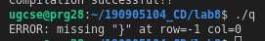

Input program
#include <stdio.h>
#include <stdlib.h>

int main()
{
int a, b;
char c;
int first, second, third[5];

while (a <= b)
{
if (second <= 5)
{
for (b = 0; b<=10; b = b + 1)
{
a = second;
}
}
}
if (second != first)
{
c = 1;
}
else
// missing {
c = 2;
}
for(i = 0; i < b; i=i+1)
{
if(i < a)
{
a = i;
}
}
}
Output
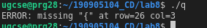

q.c

#include "lex_analyser.h"

void program();
void declarations();
void datatype();
void idList();
void idListprime();
void idListprimePrime();
void stmtList();
void stmt();
void assignStat();
void expn();
void eprime();
void simpleExpn();
void seprime();
void term();
void tprime();
void factor();
void relop();
void addop();
void mulop();
void decStat();
void dPrime();
void loopStat();

struct token tkn;
FILE *f1;

void program()
{
if (strcmp(tkn.lexeme, "main") == 0)
{
tkn = getNextToken(f1);
if (strcmp(tkn.lexeme, "(") == 0)
{
tkn = getNextToken(f1);
if (strcmp(tkn.lexeme, ")") == 0)
{
tkn = getNextToken(f1);
if (strcmp(tkn.lexeme, "{") == 0)
{
tkn = getNextToken(f1);
declarations();
stmtList();
if (strcmp(tkn.lexeme, "}") == 0)
{
printf("Compilation successful!!\n");
return;
}
else
{
printf("ERROR: missing \"}\" at row=%d col=%d\n", tkn.row, tkn.col);
exit(1);
}
}
else
{
printf("ERROR: missing \"{\" at row=%d col=%d\n", tkn.row, tkn.col);
exit(1);
}
}
else
{
printf("ERROR: missing \")\" at row=%d col=%d\n", tkn.row, tkn.col);
exit(1);
}
}
else
{
printf("ERROR: missing \"(\" at row=%d col=%d\n", tkn.row, tkn.col);
exit(1);
}
}
else
{
printf("ERROR: missing \"main\" at row=%d col=%d\n", tkn.row, tkn.col);
exit(1);
}
}

void declarations()
{
if (isdtype(tkn.lexeme) == 0)
return;
datatype();
idList();
if (strcmp(tkn.lexeme, ";") == 0)
{
tkn = getNextToken(f1);
declarations();
}
else
{
printf("ERROR: missing \";\" at row=%d col=%d\n", tkn.row, tkn.col);
exit(1);
}
}

void datatype()
{
if (strcmp(tkn.lexeme, "int") == 0)
{
tkn = getNextToken(f1);
return;
}
else if (strcmp(tkn.lexeme, "char") == 0)
{
tkn = getNextToken(f1);
return;
}
else
{
printf("ERROR: missing datatype(int or char) at row=%d col=%d\n", tkn.row, tkn.col);
exit(1);
}
}

void idList()
{
if (strcmp(tkn.type, "IDENTIFIER") == 0)
{
tkn = getNextToken(f1);
idListprime();
}
else
{
printf("ERROR: missing IDENTIFIER at row=%d col=%d\n", tkn.row, tkn.col);
exit(1);
}
}

void idListprime()
{
if (strcmp(tkn.lexeme, ",") == 0)
{
tkn = getNextToken(f1);
idList();
}
else if (strcmp(tkn.lexeme, "[") == 0)
{
tkn = getNextToken(f1);
if (strcmp(tkn.type, "NUMBER") == 0)
{
tkn = getNextToken(f1);
if (strcmp(tkn.lexeme, "]") == 0)
{
tkn = getNextToken(f1);
idListprimePrime();
}
else
{
printf("ERROR: missing \"]\" at row=%d col=%d\n", tkn.row, tkn.col);
exit(1);
}
}
else
{
printf("ERROR: missing NUMBER at row=%d col=%d\n", tkn.row, tkn.col);
exit(1);
}
}
}

void idListprimePrime()
{
if (strcmp(tkn.lexeme, ",") == 0)
{
tkn = getNextToken(f1);
idList();
}
else
return;
}

void stmtList()
{
if (strcmp(tkn.type, "IDENTIFIER") == 0 || strcmp(tkn.lexeme, "if") == 0 || strcmp(tkn.lexeme, "for") == 0 || strcmp(tkn.lexeme, "while") == 0)
{
stmt();
stmtList();
}
return;
}

void stmt()
{
if (strcmp(tkn.type, "IDENTIFIER") == 0)
{
assignStat();
if (strcmp(tkn.lexeme, ";") == 0)
{
tkn = getNextToken(f1);
return;
}
else
{
printf("ERROR: missing \";\" at row=%d col=%d\n", tkn.row, tkn.col);
exit(1);
}
}
else if (strcmp(tkn.lexeme, "if") == 0)
decStat();
else if ((strcmp(tkn.lexeme, "while") == 0) || (strcmp(tkn.lexeme, "for") == 0))
loopStat();
else
{
printf("%d.%d : Expected \" statement \"\n", tkn.row, tkn.col);
exit(0);
}
}

void assignStat()
{
if (strcmp(tkn.type, "IDENTIFIER") == 0)
{
tkn = getNextToken(f1);
if (strcmp(tkn.lexeme, "=") == 0)
{
tkn = getNextToken(f1);
expn();
}
else
{
printf("ERROR: missing \"=\" at row=%d col=%d\n", tkn.row, tkn.col);
exit(1);
}
}
else
{
printf("ERROR: missing IDENTIFIER at row=%d col=%d\n", tkn.row, tkn.col);
exit(1);
}
}

void expn()
{
simpleExpn();
eprime();
}

void eprime()
{
if (strcmp(tkn.type, "RELATIONALOPERATOR") != 0)
return;
relop();
simpleExpn();
}

void simpleExpn()
{
term();
seprime();
}

void seprime()
{
if ((strcmp(tkn.lexeme, "+") != 0) && (strcmp(tkn.lexeme, "-") != 0))
return;
addop();
term();
seprime();
}

void term()
{
factor();
tprime();
}

void tprime()
{
if ((strcmp(tkn.lexeme, "*") != 0) && (strcmp(tkn.lexeme, "/") != 0) && (strcmp(tkn.lexeme, "%") != 0))
return;
mulop();
factor();
tprime();
}

void factor()
{
if (strcmp(tkn.type, "IDENTIFIER") == 0)
{
tkn = getNextToken(f1);
return;
}
else if (strcmp(tkn.type, "NUMBER") == 0)
{
tkn = getNextToken(f1);
return;
}
else
{
printf("ERROR: Expected IDENTIFIER or NUMBER at row=%d col=%d\n", tkn.row, tkn.col);
exit(1);
}
}

void relop()
{
if (strcmp(tkn.lexeme, "==") == 0)
{
tkn = getNextToken(f1);
return;
}
else if (strcmp(tkn.lexeme, "!=") == 0)
{
tkn = getNextToken(f1);
return;
}
else if (strcmp(tkn.lexeme, "<=") == 0)
{
tkn = getNextToken(f1);
return;
}
else if (strcmp(tkn.lexeme, ">=") == 0)
{
tkn = getNextToken(f1);
return;
}
else if (strcmp(tkn.lexeme, "<") == 0)
{
tkn = getNextToken(f1);
return;
}
else if (strcmp(tkn.lexeme, ">") == 0)
{
tkn = getNextToken(f1);
return;
}
else
{
printf("ERROR: Expected RELATIONAL OPERATOR or NUMBER at row=%d col=%d\n", tkn.row, tkn.col);
exit(1);
}
}

void addop()
{
if (strcmp(tkn.lexeme, "+") == 0)
{
tkn = getNextToken(f1);
return;
}
else if (strcmp(tkn.lexeme, "-") == 0)
{
tkn = getNextToken(f1);
return;
}
else
{
printf("ERROR: Expected \"+\" or \"-\" at row=%d col=%d\n", tkn.row, tkn.col);
exit(1);
}
}

void mulop()
{
if (strcmp(tkn.lexeme, "*") == 0)
{
tkn = getNextToken(f1);
return;
}
else if (strcmp(tkn.lexeme, "/") == 0)
{
tkn = getNextToken(f1);
return;
}
else if (strcmp(tkn.lexeme, "*") == 0)
{
tkn = getNextToken(f1);
return;
}
else
{
printf("ERROR: Expected \"*\" or \"/\" or \"%%\" at row=%d col=%d\n", tkn.row, tkn.col);
exit(1);
}
}

void decStat()
{
if (strcmp(tkn.lexeme, "if") == 0)
{
tkn = getNextToken(f1);
if (strcmp(tkn.lexeme, "(") == 0)
{
tkn = getNextToken(f1);
expn();
if (strcmp(tkn.lexeme, ")") == 0)
{
tkn = getNextToken(f1);
if (strcmp(tkn.lexeme, "{") == 0)
{
tkn = getNextToken(f1);
stmtList();
if (strcmp(tkn.lexeme, "}") == 0)
{
tkn = getNextToken(f1);
dPrime();
return;
}
else
{
printf("ERROR: missing \"}\" at row=%d col=%d\n", tkn.row, tkn.col);
exit(1);
}
}
else
{
printf("ERROR: missing \"{\" at row=%d col=%d\n", tkn.row, tkn.col);
exit(1);
}
}
else
{
printf("ERROR: missing \")\" at row=%d col=%d\n", tkn.row, tkn.col);
exit(1);
}
}
else
{
printf("ERROR: missing \"(\" at row=%d col=%d\n", tkn.row, tkn.col);
exit(1);
}
}
else
{
printf("ERROR: missing \"keyword\" at row=%d col=%d\n", tkn.row, tkn.col);
exit(1);
}
}

void dPrime()
{
if (strcmp(tkn.lexeme, "else") == 0)
{
tkn = getNextToken(f1);
if (strcmp(tkn.lexeme, "{") == 0)
{
tkn = getNextToken(f1);
stmtList();
if (strcmp(tkn.lexeme, "}") == 0)
{
tkn = getNextToken(f1);
return;
}
else
{
printf("ERROR: missing \"}\" at row=%d col=%d\n", tkn.row, tkn.col);
exit(1);
}
}
else
{
printf("ERROR: missing \"{\" at row=%d col=%d\n", tkn.row, tkn.col);
exit(1);
}
}
else
return;
}
void loopStat()
{
if (strcmp(tkn.lexeme, "while") == 0)
{
tkn = getNextToken(f1);
if (strcmp(tkn.lexeme, "(") == 0)
{
tkn = getNextToken(f1);
expn();
if (strcmp(tkn.lexeme, ")") == 0)
{
tkn = getNextToken(f1);
if (strcmp(tkn.lexeme, "{") == 0)
{
tkn = getNextToken(f1);
stmtList();
if (strcmp(tkn.lexeme, "}") == 0)
{
tkn = getNextToken(f1);
return;
}
else
{
printf("ERROR: missing \"}\" at row=%d col=%d\n", tkn.row, tkn.col);
exit(1);
}
}
else
{
printf("ERROR: missing \"{\" at row=%d col=%d\n", tkn.row, tkn.col);
exit(1);
}
}
else
{
printf("ERROR: missing \")\" at row=%d col=%d\n", tkn.row, tkn.col);
exit(1);
}
}
else
{
printf("ERROR: missing \"(\" at row=%d col=%d\n", tkn.row, tkn.col);
exit(1);
}
}
else if (strcmp(tkn.lexeme, "for") == 0)
{
tkn = getNextToken(f1);
if (strcmp(tkn.lexeme, "(") == 0)
{
tkn = getNextToken(f1);
assignStat();
if (strcmp(tkn.lexeme, ";") == 0)
{
tkn = getNextToken(f1);
expn();
if (strcmp(tkn.lexeme, ";") == 0)
{
tkn = getNextToken(f1);
assignStat();
if (strcmp(tkn.lexeme, ")") == 0)
{
tkn = getNextToken(f1);
if (strcmp(tkn.lexeme, "{") == 0)
{
tkn = getNextToken(f1);
stmtList();
if (strcmp(tkn.lexeme, "}") == 0)
{
tkn = getNextToken(f1);
return;
}
else
{
printf("ERROR: missing \"}\" at row=%d col=%d\n", tkn.row, tkn.col);
exit(1);
}
}
else
{
printf("ERROR: missing \"{\" at row=%d col=%d\n", tkn.row, tkn.col);
exit(1);
}
}
else
{
printf("ERROR: missing \")\" at row=%d col=%d\n", tkn.row, tkn.col);
exit(1);
}
}
else
{
printf("ERROR: missing \";\" at row=%d col=%d\n", tkn.row, tkn.col);
exit(1);
}
}
else
{
printf("ERROR: missing \";\" at row=%d col=%d\n", tkn.row, tkn.col);
exit(1);
}
}
else
{
printf("ERROR: missing \"(\" at row=%d col=%d\n", tkn.row, tkn.col);
exit(1);
}
}
else
{
printf("ERROR: missing \"keyword\" at row=%d col=%d\n", tkn.row, tkn.col);
exit(1);
}
}

int main()
{
FILE *fa, *fb;
int ca, cb;
fa = fopen("sample.c", "r");
if (fa == NULL)
{
printf("Cannot open file \n");
exit(0);
}
fb = fopen("output.c", "w+");
ca = getc(fa);
while (ca != EOF)
{
if (ca == ' ')
{
putc(ca, fb);
while (ca == ' ')
ca = getc(fa);
}
if (ca == '/')
{
cb = getc(fa);
if (cb == '/')
{
while (ca != '\n')
ca = getc(fa);
}
else if (cb == '*')
{
do
{
while (ca != '*')
ca = getc(fa);
ca = getc(fa);
} while (ca != '/');
}
else
{
putc(ca, fb);
putc(cb, fb);
}
}
else
putc(ca, fb);
ca = getc(fa);
}
fclose(fa);
fclose(fb);
fa = fopen("output.c", "r");
if (fa == NULL)
{
printf("Cannot open file");
return 0;
}
fb = fopen("temp.c", "w+");
ca = getc(fa);
while (ca != EOF)
{
if (ca == '"')
{
putc(ca, fb);
ca = getc(fa);
while (ca != '"')
{
putc(ca, fb);
ca = getc(fa);
}
}
else if (ca == '#')
{
while (ca != '\n')
ca = getc(fa);
}
putc(ca, fb);
ca = getc(fa);
}
fclose(fa);
fclose(fb);
fa = fopen("temp.c", "r");
fb = fopen("output.c", "w");
ca = getc(fa);
while (ca != EOF)
{
putc(ca, fb);
ca = getc(fa);
}
fclose(fa);
fclose(fb);
remove("temp.c");
f1 = fopen("output.c", "r");
if (f1 == NULL)
{
printf("Error! File cannot be opened!\n");
return 0;
}
while ((tkn = getNextToken(f1)).row != -1)
{
// printf("%s\n", tkn.lexeme);
if (strcmp(tkn.lexeme, "main") == 0)
{
program();
break;
}
}
fclose(f1);
}

lex_analyser.c

#include <stdlib.h>
#include <stdio.h>
#include <ctype.h>
#include <string.h>
static int row = 1, col = 1;
char buf[2048];
char dbuf[128];
int ind = 0;
const char specialsymbols[] = {'?', ';', ':', ','};
const char arithmeticsymbols[] = {'*'};
const char *keywords[] = {"auto", "double", "int", "struct", "break", "else", "long", "switch", "case", "enum", "register", "typedef", "char", "extern", "return", "union", "continue", "for", "signed", "void", "do", "if", "static", "while", "default", "goto", "sizeof", "volatile", "const", "short", "unsigned", "printf", "scanf", "true", "false", "bool"};
const char *datypes[] = {"int", "char", "void", "float", "bool", "double"};
struct token
{
char lexeme[128];
unsigned int row, col;
char type[64];
};
struct sttable
{
int sno;
char lexeme[128];
char dtype[64];
char type[64];
int size;
};

int isKeyword(char *w)
{
for (int i = 0; i < sizeof(keywords) / sizeof(char *); i++)
if (strcmp(w, keywords[i]) == 0)
return 1;
return 0;
}
int isdtype(char *w)
{
for (int i = 0; i < sizeof(datypes) / sizeof(char *); i++)
if (strcmp(w, datypes[i]) == 0)
return 1;
return 0;
}
void newLine()
{
row++;
col = 1;
}
void printTable(struct sttable *tab, int n)
{
for (int i = 0; i < n; i++)
printf("%d %s %s %s %d\n", tab[i].sno, tab[i].lexeme, tab[i].dtype, tab[i].type, tab[i].size);
}
int findTable(struct sttable *tab, char *nam, int n)
{
for (int i = 0; i < n; i++)
if (strcmp(tab[i].lexeme, nam) == 0)
return 1;
return 0;
}
struct sttable fillTable(int sno, char *lexn, char *dt, char *t, int s)
{
struct sttable tab;
tab.sno = sno;
strcpy(tab.lexeme, lexn);
strcpy(tab.dtype, dt);
strcpy(tab.type, t);
tab.size = s;
return tab;
}
void fillToken(struct token *tkn, char c, int row, int col, char *type)
{
tkn->row = row;
tkn->col = col;
strcpy(tkn->type, type);
tkn->lexeme[0] = c;
tkn->lexeme[1] = '\0';
}
int charIs(int c, const char *arr)
{
int len;
if (arr == specialsymbols)
len = sizeof(specialsymbols) / sizeof(char);

else if (arr == arithmeticsymbols)
len = sizeof(arithmeticsymbols) / sizeof(char);

for (int i = 0; i < len; i++)
if (c == arr[i])
return 1;
return 0;
}
int sz(char *w)
{
if (strcmp(w, "int") == 0)
return sizeof(int);
if (strcmp(w, "char") == 0)
return sizeof(char);
if (strcmp(w, "void") == 0)
return 0;
if (strcmp(w, "float") == 0)
return sizeof(float);
if (strcmp(w, "bool") == 0)
return 1;
}
struct token getNextToken(FILE *fa)
{
int c;
struct token tkn =
{
.row = -1
};
int gotToken = 0;
while (!gotToken && (c = fgetc(fa)) != EOF)
{
if (charIs(c, specialsymbols))
{
fillToken(&tkn, c, row, col, "SS");
gotToken = 1;
col++;
}
else if (charIs(c, arithmeticsymbols))
{
fseek(fa, -1, SEEK_CUR);
c = getc(fa);
if (isalnum(c))
{
fillToken(&tkn, c, row, col, "ARITHMETICOPERATOR");
gotToken = 1;
col++;
}
fseek(fa, 1, SEEK_CUR);
}
else if (c == '(')
{
fillToken(&tkn, c, row, col, "LB");
gotToken = 1;
col++;
}
else if (c == ')')
{
fillToken(&tkn, c, row, col, "RB");
gotToken = 1;
col++;
}
else if (c == '{')
{
fillToken(&tkn, c, row, col, "LC");
gotToken = 1;
col++;
}
else if (c == '}')
{
fillToken(&tkn, c, row, col, "RC");
gotToken = 1;
col++;
}
else if (c == '[')
{
fillToken(&tkn, c, row, col, "LS");
gotToken = 1;
col++;
}
else if (c == ']')
{
fillToken(&tkn, c, row, col, "RS");
gotToken = 1;
col++;
}
else if (c == '+')
{
int x = fgetc(fa);
if (x != '+')
{
fillToken(&tkn, c, row, col, "ARITHMETICOPERATOR");
gotToken = 1;
col++;
fseek(fa, -1, SEEK_CUR);
}
else
{
fillToken(&tkn, c, row, col, "UNARYOPERATOR");
strcpy(tkn.lexeme, "++");
gotToken = 1;
col += 2;
}
}
else if (c == '-')
{
int x = fgetc(fa);
if (x != '-')
{
fillToken(&tkn, c, row, col, "ARITHMETICOPERATOR");
gotToken = 1;
col++;
fseek(fa, -1, SEEK_CUR);
}
else
{
fillToken(&tkn, c, row, col, "UNARYOPERATOR");
strcpy(tkn.lexeme, "++");
gotToken = 1;
col += 2;
}
}
else if (c == '=')
{
int x = fgetc(fa);
if (x != '=')
{
fillToken(&tkn, c, row, col, "ASSIGNMENTOPERATOR");
gotToken = 1;
col++;
fseek(fa, -1, SEEK_CUR);
}
else
{
fillToken(&tkn, c, row, col, "RELATIONALOPERATOR");
strcpy(tkn.lexeme, "++");
gotToken = 1;
col += 2;
}
}
else if (isdigit(c))
{
fillToken(&tkn, c, row, col++, "NUMBER");
int j = 1;
while ((c = fgetc(fa)) != EOF && isdigit(c))
{
tkn.lexeme[j++] = c;
col++;
}
tkn.lexeme[j] = '\0';
gotToken = 1;
fseek(fa, -1, SEEK_CUR);
}
else if (c == '#')
{
while ((c = fgetc(fa)) != EOF && c != '\n')
;
newLine();
}
else if (c == '\n')
{
newLine();
c = fgetc(fa);
if (c == '#')
{
while ((c = fgetc(fa)) != EOF && c != '\n')
;
newLine();
}
else if (c != EOF)
fseek(fa, -1, SEEK_CUR);
}
else if (isspace(c))
col++;
else if (isalpha(c) || c == '_')
{
tkn.row = row;
tkn.col = col++;
tkn.lexeme[0] = c;
int j = 1;
while ((c = fgetc(fa)) != EOF && isalnum(c))
{
tkn.lexeme[j++] = c;
col++;
}
tkn.lexeme[j] = '\0';
if (isKeyword(tkn.lexeme))
strcpy(tkn.type, "KEYWORD");
else
strcpy(tkn.type, "IDENTIFIER");
gotToken = 1;
fseek(fa, -1, SEEK_CUR);
}
else if (c == '/')
{
int d = fgetc(fa);
col++;
if (d == '/')
{
while ((c = fgetc(fa)) != EOF && c != '\n')
col++;
if (c == '\n')
newLine();
}
else if (d == '*')
{
do
{
if (d == '\n')
newLine();
while ((c == fgetc(fa)) != EOF && c != '*')
{
col++;
if (c == '\n')
newLine();
}
col++;
} while ((d == fgetc(fa)) != EOF && d != '/' && (col++));
col++;
}
else
{
fillToken(&tkn, c, row, --col, "ARITHMETIC OPERATOR");
gotToken = 1;
fseek(fa, -1, SEEK_CUR);
}
}
else if (c == '"')
{
tkn.row = row;
tkn.col = col;
strcpy(tkn.type, "STRING LITERAL");
int k = 1;
tkn.lexeme[0] = '"';
while ((c = fgetc(fa)) != EOF && c != '"')
{
tkn.lexeme[k++] = c;
col++;
}
tkn.lexeme[k] = '"';
gotToken = 1;
}
else if (c == '<' || c == '>' || c == '!')
{
fillToken(&tkn, c, row, col, "RELATIONALOPERATOR");
col++;
int d = fgetc(fa);
if (d == '=')
{
col++;
strcat(tkn.lexeme, "=");
}
else
{
if (c == '!')
strcpy(tkn.type, "LOGICALOPERATOR");
fseek(fa, -1, SEEK_CUR);
}
gotToken = 1;
}
else if (c == '&' || c == '|')
{
int d = fgetc(fa);
if (c == d)
{
tkn.lexeme[0] = tkn.lexeme[1] = c;
tkn.lexeme[2] = '\0';
tkn.row = row;
tkn.col = col;
col++;
gotToken = 1;
strcpy(tkn.type, "LOGICALOPERATOR");
}
else
fseek(fa, -1, SEEK_CUR);
col++;
}
else
col++;
}
// printf("%s\n", tkn.lexeme);
return tkn;
}

